Meeting December 2nd, 2018

To Do:

1. Database comparison
2. Find word searches
3. Build database for word searches

Word Searches:

1. Baby animals

Words:

* Puppy
* Foal
* Spiderling
* Kitten
* Chick
* Tadpole
* Calf
* Fry
* Lamb
* Piglet
* Fawn
* cub

1. Countries

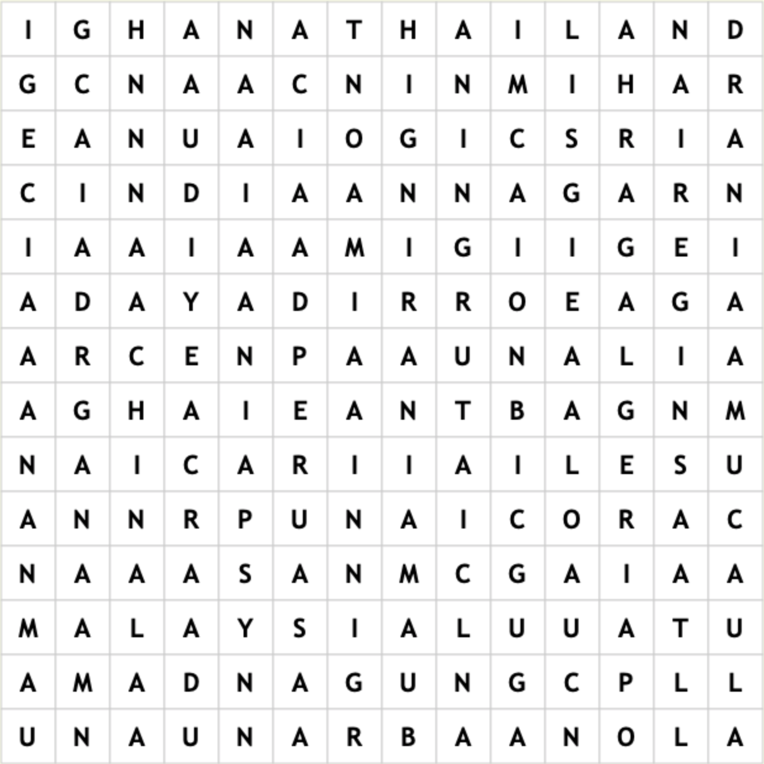

Words:

* Algeria
* Argentina
* Burma
* Canada
* China
* Congo
* Ghana
* India
* Iran
* Malaysia
* Nigeria
* Peru
* Spain
* Thailand
* Uganda

1. Types of Breakfast Food

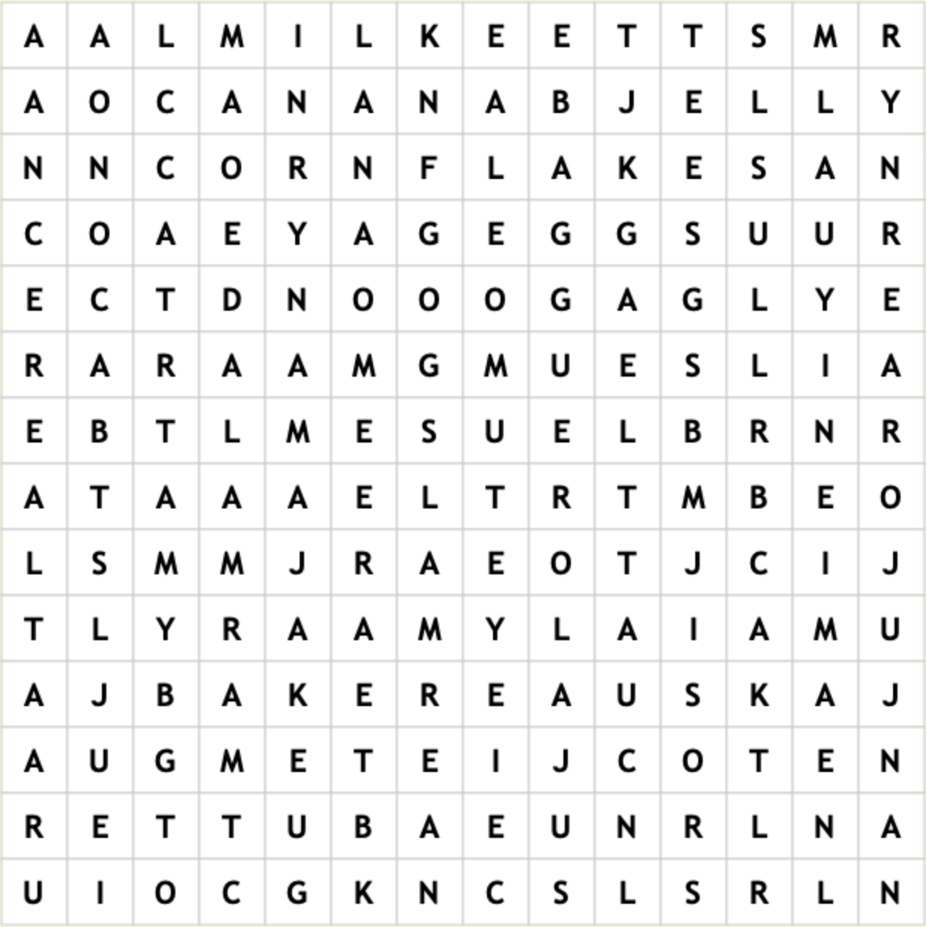

Words:

* Eggs
* Bacon
* Butter
* Toast
* Milk
* Juice
* Jelly
* Jam
* Yogurt
* Cereal
* Banana
* Cornflakes
* Muesli
* Marmalade